**Scaling localization through technology**

We all agree that companies absolutely have to localize their product in order to reach out to a global audience. Oftentimes the question is not How to accomplish that task but What tools to use to accomplish it.

**Product information Management solution**

Information kept by a business can be scattered throughout departments and held by employees or systems, instead of being available centrally; data may be saved in various formats, or only be available in hard copy form. Information may be needed for detailed product descriptions with prices, or calculating freight costs. PIM (Product information management) represents a solution for centralized, media-independent data maintenance, as well as efficient data collection, management, refinement and output.

PIM systems generally need to support multiple geographic locations, multi-lingual data, and maintenance and modification of product information within a centralized catalog.

PIM enables efficient scaling of your product and localization teams across multiple locations. Software solution for PIM such as Akeneo can improve efficiency and organization in an international company.

**Localization solutions for product descriptions**

The product descriptions are usually exported in a file format such as CSV. These files can be processed by CAT tools into individual segments and translated in the translation software.

* Human Translation

As product descriptions can be a rather large translation project, human translation can often be very slow paced and more expensive. This is where a CAT tool comes in, utilizing Translation Memory which automatically recognizes similar sentences and repetitions. These translation memory matches will drastically impact the price of the overall translation project.

* Machine translation

Machine translation such as Google Translate is generally faster and cheaper, highly scalable but result in poor quality. However, machine translation is not enough for a finished and translated product since it simply cannot automatically translate everything correctly in the right context.

* Combining Human and Machine translation

Text United has both translation memory and machine translation integrated in its system. Translators will have the option to pre-translate segments and edit them afterwards. Each edited and saved segment will also be saved in translation memory and these saved segments will appear as proposals in similar or identical segments.

The combination of human expertise and machine translation technology is the best option, since the translator will correct and adjust wrong translations, without the need to translate from scratch.

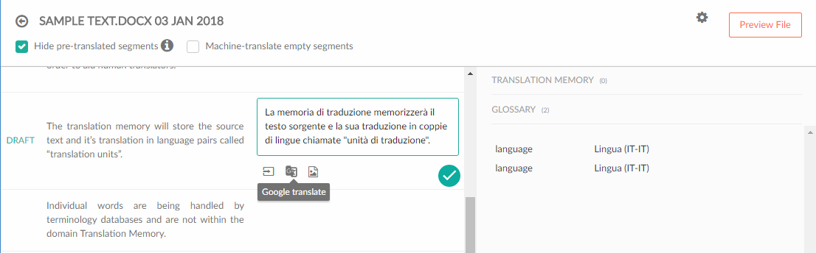

The combination of a PIM and an advanced SaaS Translation Management System will enable smooth and easy localization, which is automated but still keeps that human touch that is necessary for product descriptions.